**SB NEWS:**

**Navigate the News Landscape**

**(React Application)**

**VINOTHINI K - TEAM LEADER**

**NEHA KK - TEAM MEMBER**

**PRIYA DHARSHINI E - TEAM MEMBER**

**PRIYANGA K - TEAM MEMBER**

**MONISHA N- TEAM MEMBER**

# 

# **Abstract**

The goal of Insight SB NEWS, a dynamic, real-time news aggregation online application, is to provide organized, current news from a variety of reliable sources. To guarantee that consumers receive a well chosen and perceptive news experience, the platform makes use of AI-driven suggestions, personalized news feeds, and real-time updates.  
  
Insigh, which was developed using React.js for the front end and Node.js with Express.js for the back end, connects easily with databases and external APIs to deliver news in a dependable, streamlined manner. With category-based news categorization, intelligent filtering, and a responsive UI for easy browsing, the application is made for an intuitive user experience.

React and JavaScript are used in the frontend development of Insight Stream to guarantee a smooth and responsive user experience. Effective API connectivity and data retrieval are made possible by the backend, which is driven by Node.js and Express. The platform curates information, dynamically collects news from multiple external sources, and displays it in an easy way to use.  
  
This documentation describes the Insight Stream News Web App's implementation, usability, and scalability and acts as a thorough guide for both developers and users.

The digital age's rapid information flow has fundamentally altered how people receive news. But this change has also brought with it problems like bias, information overload, and false information. Insight Stream provides a selected, tailored, and perceptive news experience in an effort to address these problems.  
  
The platform collects, filters, and distributes news from a variety of sources by utilizing Artificial Intelligence (AI), Natural Language Processing (NLP), and Data Analytics. Users can get updates from trusted social media networks, independent journalism, and mainstream media by integrating real-time aggregation. The system uses fact-checking tools, sentiment analysis, and bias detection algorithms to preserve transparency and credibility.

**Personalized News Feed**: To provide a customized news experience, the platform adjusts to user preferences and reading habits.

**AI-generated summaries**: Increase efficiency by enabling users to rapidly understand the main ideas of news items.

**Comprehensive Insights**: Users can better comprehend historical and international viewpoints on news events by using contextual information.

**Interactive data visualizations**: showcasing popular subjects and new stories from various sectors and geographical areas.  
Insight Stream incorporates user interaction technologies to promote meaningful conversations, fostering an informed community where dialogues are checked for accuracy and genuineness. The system guarantees a seamless and accessible user experience because it is made for both web and mobile platforms.

Insight Stream wants to revolutionize digital news consumption with its user-centric, transparent, and intelligent approach. With its accurate, varied, and significant news insights, it empowers readers to navigate the complicated world of contemporary media with confidence.

**Table Of Contents**

**Introduction**: Overview of the project and its significance.  
  
**Project Goal**: Goals and anticipated results.  
  
**Pre-requisites**: Necessary dependencies and tools.  
  
**Project Structure**: System architecture and folder organization comprise the project structure.  
 **Configuration & Setup**: Detailed installation instructions.  
  
**Testing**: Techniques for confirming performance and dependability.  
  
**Data Flow Diagrams**: Data flow diagrams show how systems interact with one another.  
  
**Code Editor(VS Code)**: Recommended development environment.  
  
**Conclusion**: Synopsis and upcoming improvements.

**Introduction**

It has grown more difficult to find trustworthy and objective news in the fast-paced digital world of today. Users frequently find it difficult to distinguish between reliable information and deceptive material due to the abundance of news sources available. By providing a structured, real-time news aggregation platform that guarantees truth, transparency, and efficiency in news consumption, SB NEWS aims to close this gap.

In order to weed out false material, SB NEWS uses fact-checking algorithms and bias detection techniques to compile news from a variety of reliable sources. Users may rapidly understand important points from long articles by utilizing AI-driven summary, making reading the news more effective and interesting. Additionally, the platform offers category-based filtering, which lets users customize their feeds according to their interests, be they entertainment, politics, technology, or health.

An important feature of SB NEWS is its user-friendly interface, which is made to offer smooth navigation and an eye-catching experience. While AI-powered suggestions provide individualized news based on user interests, the platform's real-time updates guarantee users keep up to current with the most recent headlines.

SB NEWS transforms the way people consume news by fusing state-of-the-art technology with a user-centric approach, making it more approachable, educational, and captivating than ever. Regardless of your level of interest in news, SB NEWS gives you the resources you need to always be informed on well-curated, fact-based, and impartial news.

**Project Goal**

Insight Stream uses sophisticated AI algorithms to tailor news recommendations since it understands that every person has different preferences. The platform creates a personalized news feed based on user interests, browsing history, and hot topics, enabling users to stay informed on topics that are most important to them.

With these guiding concepts, Insight Stream makes news consumption more intelligent, effective, and interesting. The website makes sure consumers have access to pertinent, excellent, and objective news, regardless of whether they are looking for in-depth analyses or brief summaries.

**Description**

A cutting-edge news aggregation technology, Insight Stream provides real-time information from numerous reliable sources. It is made to make digital news consumption easier and provides a customized, organized, and clutter-free experience. By choosing categories like politics, technology, business, and entertainment, users can personalize their news feed and make sure they only see stuff that interests them.  
  
Users can easily get news from PCs, tablets, and smartphones thanks to the platform's AI-driven suggestions, real-time updates, and multi-device compatibility. News browsing is made more efficient and entertaining by its user-friendly interface, which also improves navigation.  
  
Insight Stream uses strong authentication and encryption procedures to safeguard user data in order to put security and privacy first. It guarantees that the information provided is impartial, current, and accurate by utilizing APIs from reputable news sources.

Through the integration of cutting-edge technology and astute content curation, Insight Stream enables users to navigate the rapidly evolving news landscape of today with confidence and knowledge.

**Pre-requisites**

* Development Environment: Set up npm and Node.js to run the backend and manage dependencies.
* Frontend Technologies: To produce a responsive, user-friendly design, the project makes use of React.js, Bootstrap, Tailwind CSS, and Material UI.
* Backend Technologies: To effectively handle data and manage API requests, the backend is constructed with Node.js and Express.js.
* Database: User preferences, news information, and other application-related data are stored in MongoDB, which serves as the main database.
* API Integration: To deliver up-to-date information and pertinent news articles, external news APIs are incorporated.
* Version Control: Source code management, teamwork, and version history maintenance are accomplished with Git and GitHub.
* Code Editor: Because of its smooth development experience and strong extension support, Visual Studio Code (VS Code) is advised for development.

**Technologies Used**

The Insight Stream news app makes use of contemporary web technology to guarantee a smooth, effective, and intuitive user experience. The main technologies used in the project are listed below:

**Frontend technologies:**

* **React.js**: Used for building the user interface with reusable components.
* **JavaScript:** Enhances interactivity and application logic.
* **CSS3 & SCSS**: Styles the application for a visually appealing layout.
* **Material UI**: Provides pre-styled UI components for a modern look and feel.

**Backend technologies:**

* **Node.js**: Handles server-side operations efficiently.
* **Express.js**: Manages API routes and request handling.
* **MongoDB**: A NoSQL database for storing user preferences and cached news data.
* **Mongoose**: A schema-based solution to model MongoDB data.

**Development Tools & Environments:**

* VS Code: Recommended code editor for development.
* Postman: Used for testing API endpoints.
* Git & GitHub: Version control and repository management.

**APIs & External Integrations:**

* **NewsAPI or NY Times API**: Fetches real-time news articles from trusted sources.
* **JWT (JSON Web Token):** Implements authentication and secure user sessions.

**Project Structure**

The project follows a well-organized folder structure:

Insight Stream/

│── backend/

│ ├── server.js

│ ├── routes/

│── frontend/

│ ├── src/

│ │ ├── components/

│── config/

│── tests/

│── README.md

│── package.json

# **Installation:**

Use these procedures to launch the Real-time News Web App locally:

1. Use npm install to set up frontend dependencies in the root directory.

2. Use npm start to launch the frontend server after navigating to the frontend directory.

3. Install the Node.js server and get the backend files from the Google Drive link supplied.

4. Run dev with npm.

Make that MongoDB is set up and installed for database administration.

**Testing**

Extensive testing is necessary to guarantee the platform runs smoothly. To verify various components and preserve system dependability, Insight Stream uses a mix of manual testing, integration testing, and unit testing.

* Unit Testing: To make sure individual components operate as intended, Jest is used for testing. The following command allows developers to perform unit tests:
* API Testing: Postman is used to test API endpoints, ensuring that they operate without hiccups and provide accurate responses.
* Integration Testing: To ensure seamless platform interaction, several modules are evaluated in tandem.
* Manual Testing: Practical testing aids in finding problems and improving the user experience in general.

Insight Stream provides a solid, effective, and dependable news aggregation experience by putting these testing techniques into practice.

**Screenshots**

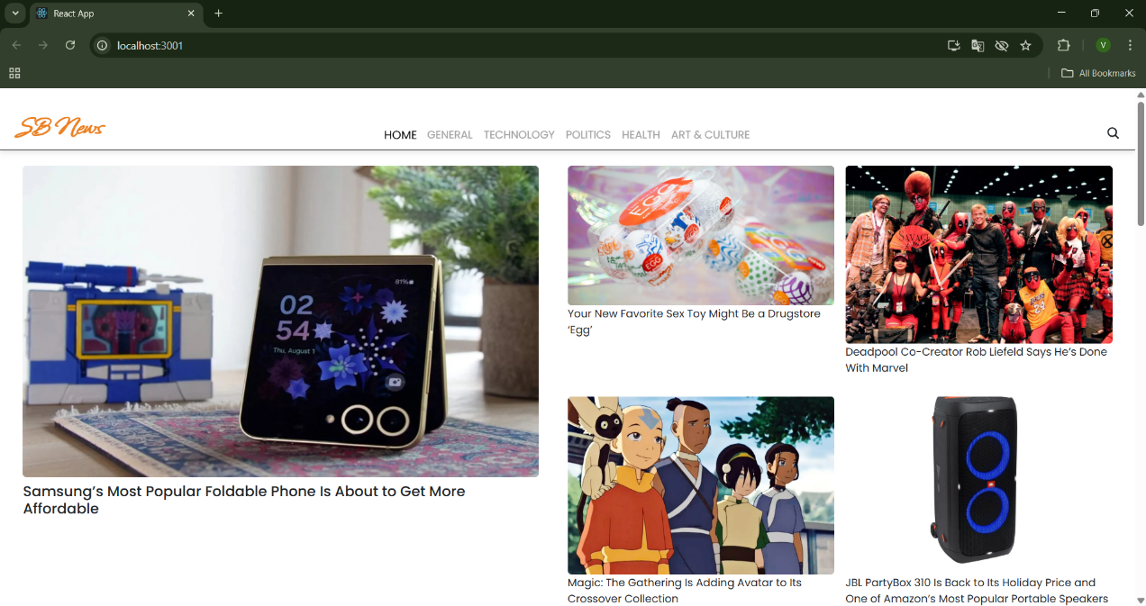

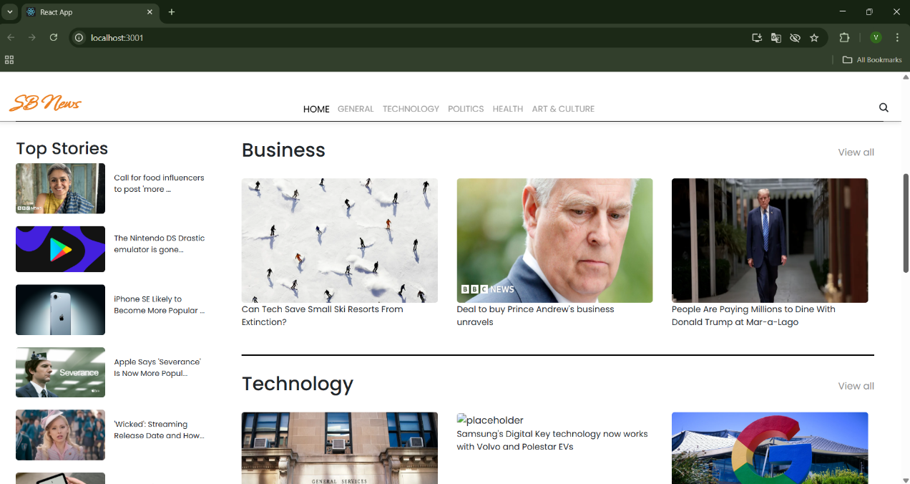

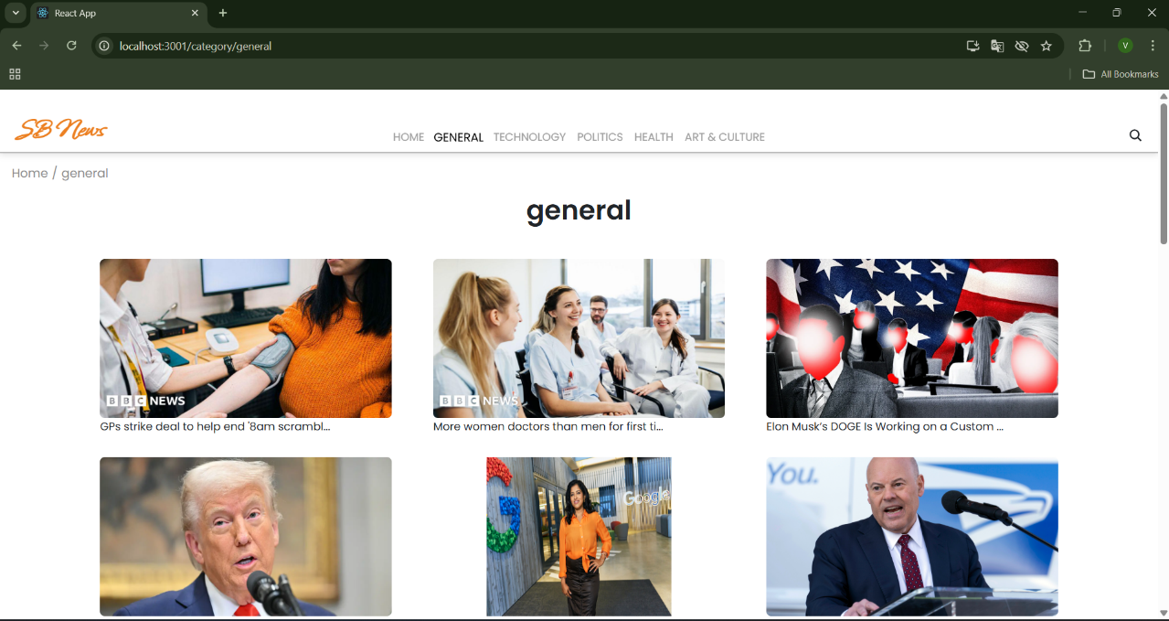

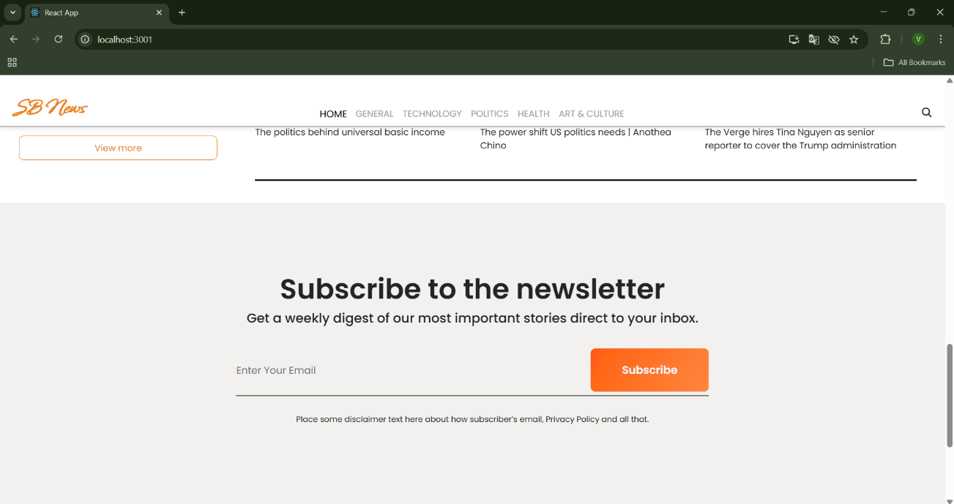

**Data Flow Diagram**

1. By choosing news categories or conducting topic searches, the user engages with the online interface.   
   2. To retrieve the most recent news articles from integrated sources, the program sends API queries.   
   3. Filtering parameters are used to process and organize the received data.

**Conclusion**

Since the media landscape is always changing, news platforms must be flexible and creative. Insight Stream was created to offer a dependable, organized, and easy-to-use news aggregation experience. The platform will incorporate new technologies as it expands to improve user engagement and interactivity even further.

Sentiment analysis, which provides information on the bias and tone of news pieces, is what Insight Stream hopes to introduce in the future.

Artificial intelligence (AI)-generated summaries offer succinct, insightful summaries for rapid and effective news consumption.

Enhanced Regional Support: Providing multilingual and regionally specialized news coverage to reach a wider audience.

More than just a news aggregator, Insight Stream is a cutting-edge platform made to assist users in navigating the complicated world of news in a personalized and simple manner. The aims and purposes of Insight Stream.

The backend and frontend development components of the technical framework. The tactics used for testing, deployment, and launch.  
Insight Stream has the ability to completely transform the way people consume news thanks to its state-of-the-art technology and user-centric design.

It makes finding news easier, promotes critical thinking, and keeps users informed and involved. By bridging the gap between information overload and clarity, the platform hopes to become the ultimate news companion as it develops.